Name: __Emma Jebe___________ CURRICULUM PLANNING TOOL

Unit Big Idea: Identity Grade Level: 5th Illinois Fine Art Goals:

Unit Key Concepts and Essential Questions:
- Creativity and innovative thinking are essential life skills that can be developed.
- Art is used to express thoughts, ideas, and emotions.
- Art materials are tools that help artists communicate thoughts, ideas, and emotions.
- Art is a means of discovery.
- Art thoughts come from those actively searching for them.
- Artists express opinions about people, events, and society
- What conditions, attitudes, and behaviors support creativity and innovative thinking?
- What factors prevent or encourage people to take creative risks?
- Collaboration can expand the creative process.

Session | Title of Lesson/  Expected Result[s]  [& Length of Time to Completion] | LP Key Concepts  [list the IMPT concepts about the big idea] | Dialogue/Concepts  [Essential Questions you will ask; points of discussion; what they are learning] | Historical/MC & Contemporary Art Exemplars  [artworks, books, artists, visitors, interviews, videos] | Key Artistic Concepts  [conceptual understandings, materials, techniques] | Instructional/Artmaking Activities  [Bullet point step by step procedures for the activities] | Closure/  Assessment  [how you will wrap it up and how you will grade the lesson’s results]
Week 1 | Discovering Artistic Identities  Sketchbooks  40 min | - Creativity and innovative thinking are essential life skills that can be developed by using sketchbooks.  - Sketchbooks are a means of personal discovery.  - Art thoughts come from those actively searching for them.  - Trusting personal experience to experiment with new ideas of creativity  Vocabulary  Bookbinding; Sketchbook; Spine; Stitching; Reflection; Identity | - How can creativity and innovative thinking be developed in sketchbooks?  - How is art a means of personal discovery?  - How can an artist actively search for art thoughts?  - How do artists learn from trial and error? | Frida Kahlo’s Sketchbook  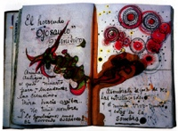  Paul Cezanne’s Sketchbook  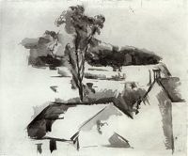  Vincent Van Gogh’s Sketchbook  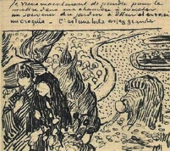  Bring in one of my own sketchbooks | - Bookbinding  - Stitching  - Reflecting | - Get 10 pieces of white paper, choose at least 2 mediums (marker, colored pencil, crayons, pens) and a piece of cardstock  - Neatly fold 10 pieces of white paper and 1 piece of cardstock in half and punch 3 holes near the folded edge.  - Thread string through the two holes farthest apart from the back of the book  - Thread both of the ends of the string through the middle hole  - Tie a knot around the first stitch you made  - Write name legibly on the front cover  - Decorate the cover in a way that reflects who you are. | - How can a sketchbook be used to support creativity and innovative thinking?  - How can you use your sketchbook as a means of discovery  - How does the cover of your sketchbook reflect your identity?  Students will be graded based on a rubric including concept; effort; construction; presentation  In their sketchbooks, students will write one thing that they are excited about in art, one thing they are not excited/worried about in art, and anything they would like me to know about them.
Week 2 | A Personality Portrait  Symbolic Portraits  40 min | - Art is used to express thoughts, ideas, and emotions.  - Art materials are tools that help artists communicate thoughts, ideas, and emotions.  - Art thoughts come from those actively searching for them.  - Artists express opinions about people, events, and society  - Collaboration can expand the creative process.  Vocabulary:  Symbols; pictogram; identity; expression; | - What makes a person who they are?  - How are traits and characteristics illustrated?  - How does collaboration expand the creative process?  - What factors prevent or encourage people to take creative risks? | Jean-Michel Basquiat  King of the Zulus  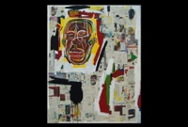  Jean-Michel Basquiat and Andy Warhol  Ailing Ali In Fight of  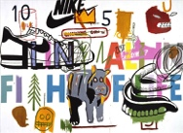  Frida Kahlo  Self-Portrait with Necklace of Thorns  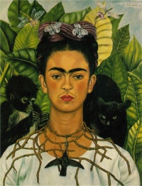 | - Collaboration  - Symbolism  - Visual Representation | - Write down 10 traits, descriptive words, or interests that have to do with your Identity on a page in your sketchbook  - Pass your book to the next person  - Consider how one of the traits could be depicted visually  - Draw 1 trait in 30 seconds  - Cross out the trait you used and pass paper to the next student  -After 5 traits are used, consider what traits are more difficult to illustrate and share ideas  - Consider how the same words can be depicted differently  - Continue until all traits are used  - Give original student their portrait  - consider what symbols stand out to you | - Discuss whether or not they think their portraits represent themselves or not and why.  - Consider any chances or risks you might have took in depicting traits  - How did collaborating affect the process?  - What is identity?  - How can identity play a role in your art?  - How can art be used to express thoughts, ideas, and emotions?  - How can art be to communicate thoughts, ideas, and emotions?  Students will be graded based on a rubric including concept; effort; construction; presentation  Students will write a paragraph in their sketchbooks discussing who they are, what factors might have had a part in shaping their identity, and other ways they might integrate their identity into their art.  If they finish early, students will write one high from today, one low from today, and one hah (funny occurrence) from today.
Week 3 and 4 | Monochrome Moods  Monochrome Painting  40 min for 2 days | - Collaboration can expand the creative process.  - Art is used to express thoughts, ideas, and emotions.  - Art materials are tools that help artists communicate thoughts, ideas, and emotions.  - Artists express opinions about people, events, and society  - What factors prevent or encourage people to take creative risks?  Vocabulary  Color; Symbolism; Blue Period; Collage; Monochrome; Acrylic; Two Dimensional; Three Dimensional; Pattern; Rhythm; Tone; Shade; Color Wheel; Analogous colors; | - How can color be used to express thoughts, ideas, and emotions?  - How can texture and varying surfaces enhance the Artist’s thoughts, ideas, and emotions  - How can color communicate an artist’s opinion about people, events, and society?  - Does limiting the work to one color prevent or encourage an artist to take creative risks? | Disney Pixar  Inside Out  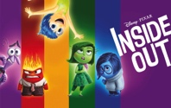  Picasso  The Tragedy  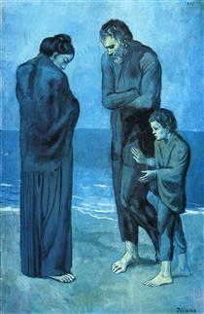  Starwars  Darth Vader  Vincent Van Gogh  Sunflowers  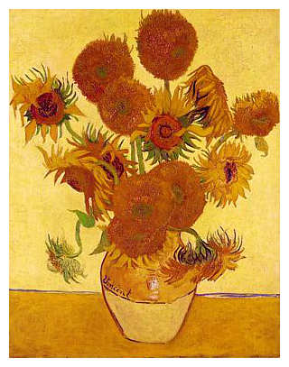  Barnett Newman  Dionysus | - Collage: cutting, pasting, gluing, tearing  - Rhythm, Pattern  - Mixing colors: toning, shading, analogous  - Mixed Media  - Expression | - Choose a memory associated with strong feelings  - Write three to five sentences describing the memory, the way you felt during the memory, and the way you feel now as you remember the memory in your sketchbook.  - Spend 3 minutes sketching how you will depict the memory  - Choose either collage, painting, or both  - Choose a color to best express the emotions surrounding that memory.  - If you are collaging, get a piece of paper, glue, and materials that are the color you chose, a tint of the color you chose, a shade of the color you chose, and analogous to the color you chose.  - If you are painting, get a piece of paper, a paintbrush, the color you chose, black, white, and at least one analogous color.  - Spend 15 minutes working | - Discuss paintings and how they make you feel.  - Discuss how the color limit prevented or encouraged you to take risks.  - Discuss how texture and varying surfaces were used to express emotion.  - Discuss how color was used to express emotion.  - Discuss the differences and similarities between the collages and the paintings.  Students will be graded based on a rubric including concept; effort; construction; presentation  If they finish early, students will write one positive and one negative from that class and sketch in their sketchbooks.
Week 5 | Surrealist Spirit Animals  Surreal Watercolor Painting  40 min | - Creativity and innovative thinking are essential life skills that can be developed.  - Art materials are tools that help artists communicate thoughts, ideas, and emotions.  - Art is a means of discovery.  - Art thoughts come from those actively searching for them.  - What conditions, attitudes, and behaviors support creativity and innovative thinking?  Vocabulary  Watercolors; Identity Surrealism; Rational Thought; Irrational; Distortion; Primary Colors; Secondary Colors; Tertiary Colors; Crayons; Spirit Animal; Symbolism | - How can using new materials develop creativity and innovative thinking?  - How can adding other mediums help communicate an idea?  - How does rational thought encourage or prevent creative and innovative thinking? | Vladmir Kush  African Sonata  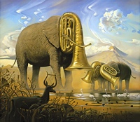  Salvador Dali  The Elephants  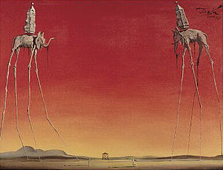 | - Visual Representation  Watercolor Techniques  - Wax Resist  - Wet-on-wet  - Dry brush  - Dry-on-Wet  - Wet-on Dry  - Flat Wash  - Gradated Wash  Distorting | - Get out sketchbook and a pencil  - Consider three different animals and write down three characteristics of each  - Consider and choose which animal you identify with the most  - Write down three key characteristics describing yourself that would never be used to describe that animal  - Spend 3 minutes sketching possible ways to physically distort your animal using at least one of those traits.  - Get a box of crayons, watercolors, a brush, a cup of water, and a piece of watercolor paper  - Spend 5 minutes drawing the distorted animal with crayon  - Using at least 2 of the watercolor techniques, paint your animal and background. | - How did irrationality encourage or prevent creative and innovative thinking?  - Was it difficult or easy to abandon rational thought?  - What did you discover during this process?  - How can animals be used symbolically?  - How can animals represent identity?  - How can distortion be used to communicate thoughts, ideas, and emotions?  - What is the reasoning behind the distorted characteristic?  Students will be graded based on a rubric including concept; effort; construction; presentation  If they finish early, students will write one thing they enjoyed about distortion and one thing they did not like about distortion and sketch in their sketchbooks.
Week 6 | Pieced Together Pastel Portraits  Oil Pastel Self Portrait  40 min | - Collaboration can expand the creative process.  - Art is used to express thoughts, ideas, and emotions.  - Art materials are tools that help artists communicate thoughts, ideas, and emotions.  - Art is a means of discovery.  - Art thoughts come from those actively searching for them.  Vocabulary  Oil Pastels; Self-Portrait; Pigment; Gradation; Sgraffito; Stipple; Contour; Crosshatch; Cubism; Fragments | - How does collaboration expand the creative process?  - How can art be used to express your identity  - How can materials be used to further communicate thoughts, ideas, and emotions?  - How can art be used for self-discovery  - How can viewing other artists’ works be beneficial? | Pablo Picasso  Weeping Woman  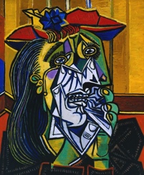  Salvador Dali  Cubist Self-Portrait  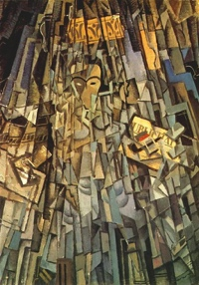 | - Blending  - Scraping  - Stippling  - Crosshatching  - Contouring | - Get out sketchbook, a box of oil pastels, and a sheet of black paper  - Practice different oil pastel techniques in sketchbooks  - Find a partner  - Consider the shapes found in a person’s face  - Observe at their face from multiple angles  - For 1 minute, draw one partner’s face in their sketchbook using only straight lights.  - For 1 minute, draw the opposite partner’s face in their sketchbook using only straight lights.  - Consider how easy or difficult the process was.  - Share any problems, thoughts, questions  - Using the contour drawing as inspiration and at least 2 of the different techniques draw a self-portrait | - How much did the contour drawing influence the self-portrait?  - How does the portrait express one’s identity  - Was color an important factor? Why or why not?  - Did the process reveal anything about you?  - Do the portraits reveal anything about another student?  - How did the cubist self-portraits influence the artwork?  Students will be graded based on a rubric including concept; effort; construction; presentation  If they finish early, students will write one reflection from today’s class and one negative reflection from today’s class and sketch in their sketchbooks.
Week 7 | Wrap Up  Completed Projects  40 min | - Creativity and innovative thinking are essential life skills that can be developed.  - Art is used to express thoughts, ideas, and emotions.  - Art is a means of discovery.  - Art thoughts come from those actively searching for them.  - Many conditions, attitudes, and behaviors support creativity and innovative thinking.  - Many factors can prevent or encourage people to take creative risks. | - How can creativity and innovative thinking skills be developed?  - How is art used to express thoughts, ideas, and emotions?  - How is art a means of discovery?  - What conditions, attitudes, and behaviors support creativity and innovative thinking?  - What factors can prevent or encourage people to take creative risks? | Nick Cave  Exploring Identity Through the Arts  https://www.youtube.com/watch?v=xRBVoBhUv1w | - Artistic Identity | - Work on any unfinished projects  - If finished, choose your favorite artwork and write an artist statement by describing your artwork, explaining how you created it, discussing the big idea of it, and your overall thoughts of your artwork. | - Discuss favorite artworks from the class and why.  - Discuss different ways we developed creativity and innovative thinking skills.  - Discuss how art is used as a form of expression  - Discuss how we used art to learn about who we are as artists  - Discuss conditions, attitudes, and behaviors needed to support creativity and innovative thinking.  - Discuss factors that encourage creative risk taking.  If they finish early, students will write 2 sentences describing their favorite medium, what they have learned about themselves as artists, and sketch in their sketchbook.

